Assignment 4

Ajf434

Aaron fosmire

Collaborators Nate and Malay Joe

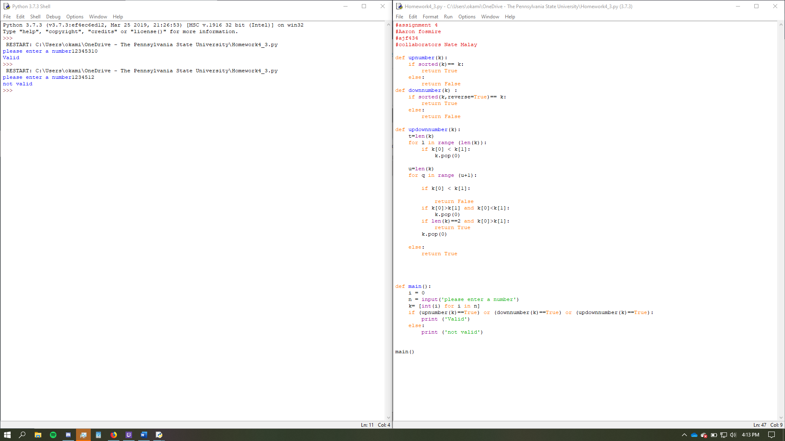

#assignment 4

#Aaron fosmire

#ajf434

#collaborators Nate Malay

def upnumber(k):

if sorted(k)== k:

return True

else:

return False

def downnumber(k) :

if sorted(k,reverse=True)== k:

return True

else:

return False

def updownnumber(k):

t=len(k)

for l in range (len(k)):

if k[0] < k[1]:

k.pop(0)

u=len(k)

for q in range (u+1):

if k[0] < k[1]:

return False

if k[0]>k[1] and k[0]<k[1]:

k.pop(0)

if len(k)==2 and k[0]>k[1]:

return True

k.pop(0)

else:

return True

def main():

i = 0

n = input('please enter a number')

k= [int(i) for i in n]

if (upnumber(k)==True) or (downnumber(k)==True) or (updownnumber(k)==True):

print ('Valid')

else:

print ('not valid')

main()